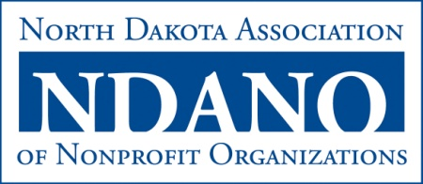
Emerging Leader Award
The Emerging Leader Award is given to an individual who has made a significant impact in strengthening the North Dakota nonprofit sector in a short amount of time through his/her commitment to leadership, volunteerism, and/or philanthropy. Individuals with 15 years or less of leadership experience are eligible for this award.

2014 NOMINATION FORM

Individual Nominee
Title
Organization/Affiliation
Mailing Address
Phone
Email

- Describe how the nominee displays exceptional leadership skills and character, including any other awards received.

- Outline which nonprofits the nominee has been involved with and how these organizations have been strengthened from his/her involvement.

- Give two to three examples of how the nominee has made a difference in his/her community, region, and/or state and the North Dakota nonprofit sector through leadership, volunteerism, and/or philanthropy.

Nominated by
Organization/Affiliation
Mailing Address
Phone
Email
Date

