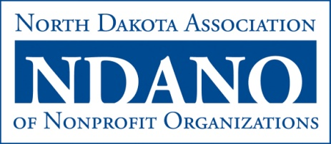
Partnership Building Award
The Partnership Building Award (formally Innovation Award) is given to an organization that has demonstrated community leadership and built partnerships within the North Dakota nonprofit sector. Nonprofits, for-profit businesses, government agencies, and educational institutions are eligible for this award.

2014 NOMINATION FORM

Organization Nominee
Contact Person
Mailing Address
Phone
Email
- Describe how the nominee has taken initiative to provide community leadership and build partnerships within the state nonprofit sector, including two to three specific examples of these activities.

- Explain how the nominee has made a difference in his/her community, region, and/or state and the North Dakota nonprofit sector through its leadership and partnerships

- List any significant national, regional, state, or local recognition or awards received by the nominee.

Nominated by
Organization/Affiliation
Mailing Address
Phone
Email
Date

