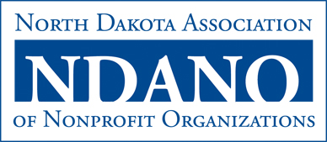

Board Candidate Biographical Data Form

This form is designed to help NDANO’s Governance Committee identify potential board member interests and experience and how these talents can benefit NDANO, its membership and the state nonprofit sector.

Name: (Include professional designations, i.e. M.S.W., Ph.D., etc.)

Organization Affiliation: (Note if retired)

Title/Position:

Address: (Contact information is business or home)

Phone:

Fax:

Email:

Organization Subsector: (Check one)
Arts/Culture/Humanities
Education
Environment/Animals
Health
Human Services
International
Public/Societal Benefit
Religious

Organization Staff Size: (Check one)
1
2-5
6-9
10+

Areas of YOUR Expertise: (Check all that apply)
Accounting/financial management
Advocacy/public policy
Communications/marketing
Fundraising
General administration
Human resources
Meeting/event planning
Membership
Project/program management
Public relations
Research
Technology
Volunteer management

Boards and committees you currently serve on or have served on, along with any other community volunteer activities:

How do you feel NDANO would benefit from your involvement on the board?

Please tell us anything else you’d like to share.

Thank you for your interest in serving on the NDANO Board of Directors!

