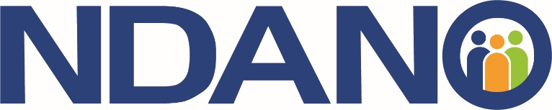
FOR IMMEDIATE RELEASE
April 17, 2023

North Dakota Association
Of Nonprofit Organizations
Dana Hager, Executive Director
701-258-9101
director@ndano.org
www.ndano.org

North Dakota Nonprofit Leadership Conference Announced

The North Dakota Association of Nonprofit Organizations (NDANO) announces speakers and open registration for the 2023 Nonprofit Leadership Conference in Fargo on June 7-8.

The annual two-day event is an educational and networking opportunity bringing together nonprofit leaders from across the state. NDANO hosts the premier gathering of nonprofit leaders as part of its mission to educate and connect the nonprofit community in North Dakota.

The conference will begin at 10:30 a.m. on June 7 with an opening keynote from tech guru Beth Z. of Your Nerdy Best Friend. Additional featured speakers include Patrick Kirby of Do Good Be Better Consulting, public relations expert Rob Keller from the North Dakota Public Information Officer Association, and North Dakota business coach and speaker Ryan Botner from Cornerstone Speaking and Coaching. The full agenda can be found at ndano.org.

"There are real and tangible benefits to attending a conference like this," NDANO Executive Director Dana Hager said. "The leadership conference presents the perfect opportunity to network with other thought leaders, learn from experts, and build community."

NDANO is the statewide membership association for the North Dakota nonprofit sector. Members work in all mission areas, from human services and the environment to education and the arts, and represent all sizes of nonprofits, from small volunteer-run to multi-million-dollar organizations. Membership is not required to attend the conference.

Exhibitor booths and sponsorships are available for businesses and organizations interested in having a presence at the conference.

For more information on NDANO or the conference, visit www.ndano.org or call 701-258-9101.

###

